**Installation Steps**

1. Unzip the folder EHRs
2. Run “npm install” from project location
3. Run “npm install -g truffle”
4. Run “npm install -g ganache-cli”
5. This is how the package.json file will look

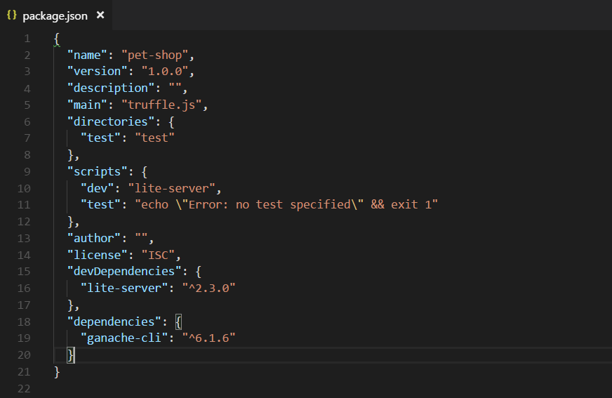

1. Run “truffle test” to make sure all contracts are running fine

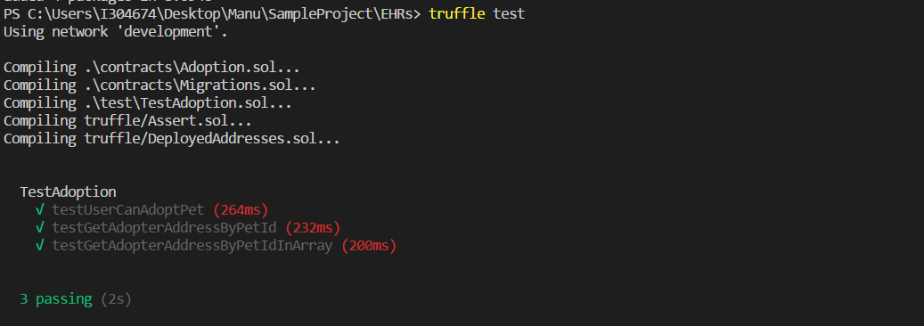

1. Run “npm run dev” to start the project
2. Launch the application on **chrome** : <http://localhost:3000/>

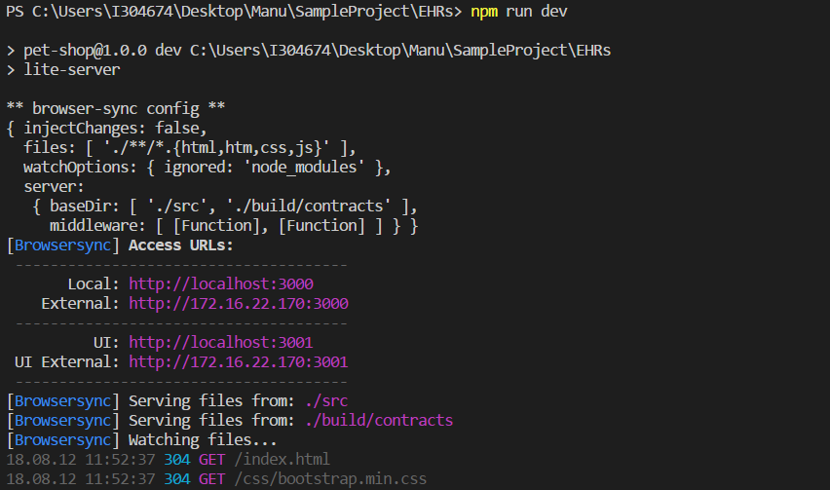

**Test Document**

1. Metamask page

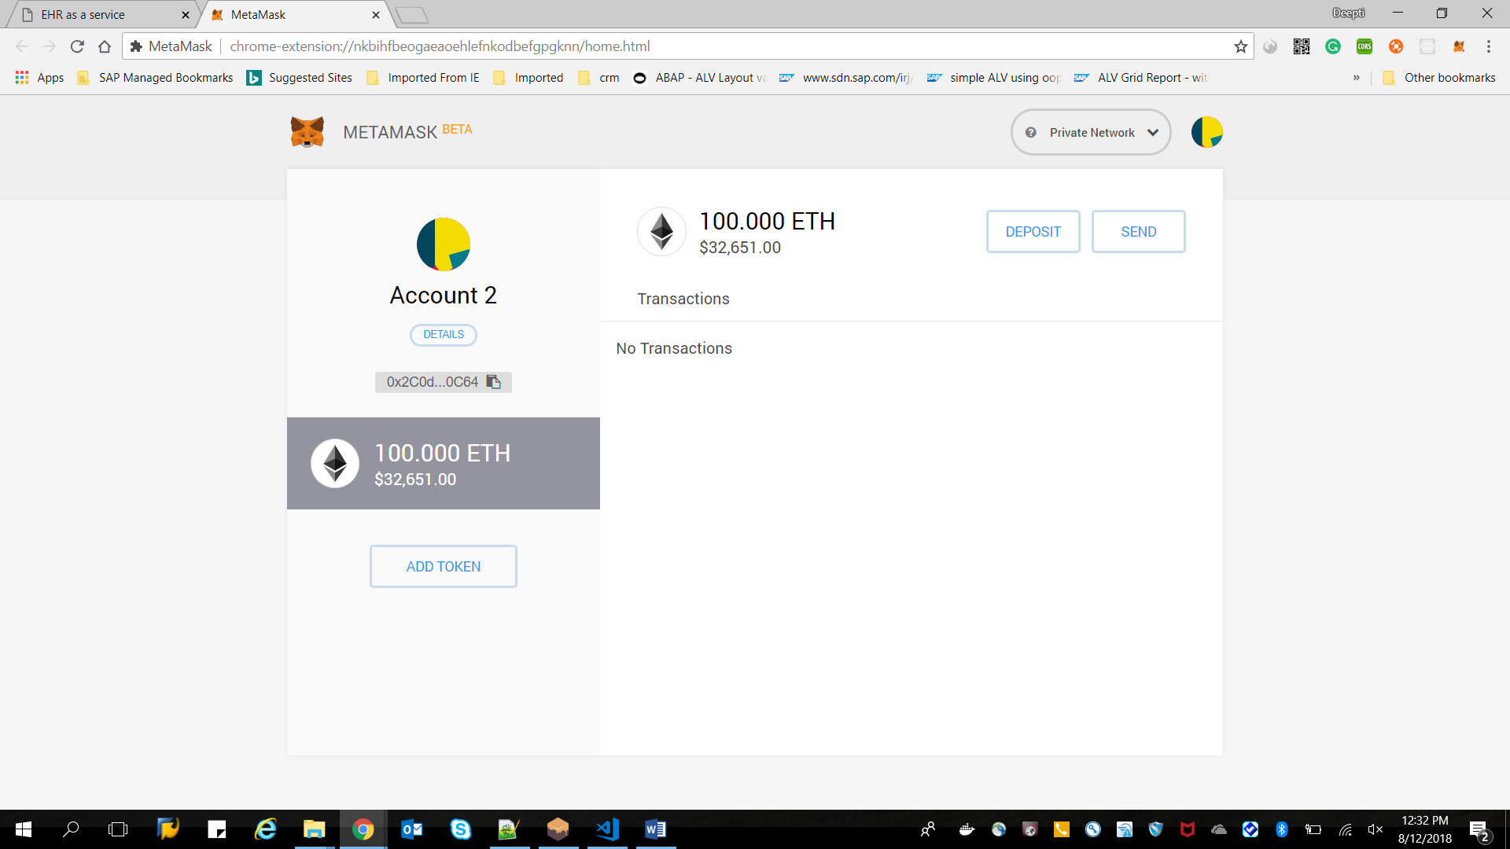

1. EWRs page for Query and Retrieve
2. Ganache server for handling Ethereum network and ETH transactions

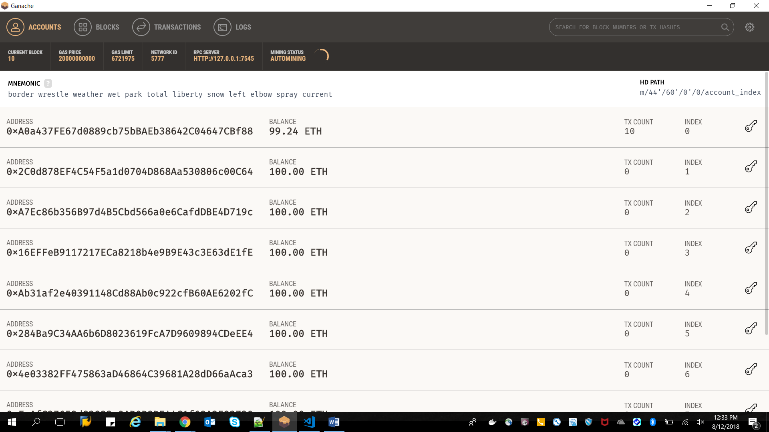

1. Click on “Retrieve” to retrieve the records
2. Confirm Metamask transaction

Transaction confirmed. ETH consumed. Number of blocks increased by 1

